Blanket Study Abroad FAQs
- What is the UT System Blanket Study Abroad Insurance Program?

In order to protect all students traveling abroad, The University of Texas System has created a blanket insurance program. All United States citizens, permanent residents of the United States or international students in the United States who are enrolled as students at the University and travelling abroad on a UT System institution study abroad or related educational activity outside his/her Home Country, including co-curricular and extra-curricular activities done in relation to their scholastic program while outside of the United States and their Home Country are covered by this program.

All students are automatically enrolled by registering their trip information through MyTrips on the UT System ISOS webpage and must have this insurance as a requirement of studying abroad on a UT Sponsored program. ALL students traveling internationally on a university-sponsored trip are required to register with International SOS prior to travel. It is imperative all students use the ISOS MyTrips to ensure coverage is seamless.

UT System Administration will send one invoice to each institution late in the fall of each year based on the travel data reported in the Risk Management International Travel Survey conducted each spring.

- What is the weekly premium for this program?

The estimated per week cost for the blanket study abroad insurance program, based on anticipated travel for UT System, is $14.18 per week.

The breakdown of this cost is $12.67 per week for the medical insurance coverage (AHP/ACE) and $1.51 per week for ISOS assistance.

- Where can we find the brochure, ID card and claim form?
The brochure and other forms can be found on the AHP Study Abroad Website: https://utstudyabroad.myahpcare.com/
Information about ISOS, the ISOS contact card and how to register trip information in MyTrips can be found here: https://www.internationalsos.com/members_home/login/login.cfm
Enter 11BSGC000037 in the Member Number field at the upper right of the page.
- It is okay to leave empty the ID# field in the temporary card as the insurance company will base its information on what ISOS provides.
Yes, as long as that’s ok with the consulate or whatever the student needs. The policy number could be used as the ID if it’s needed. Policy #GLMN04969340

- Will ISOS provide the insurance company student names and coverage period dates?
ISOS and ACE are working very closely together. Please see the flow chart below. ISOS will provide ACE the student coverage information. AHP is still involved and will be helping ACE on the customer service side of things, so if ever there is an issue and ISOS cannot help, please contact AHP.
For contact information please see the last question.

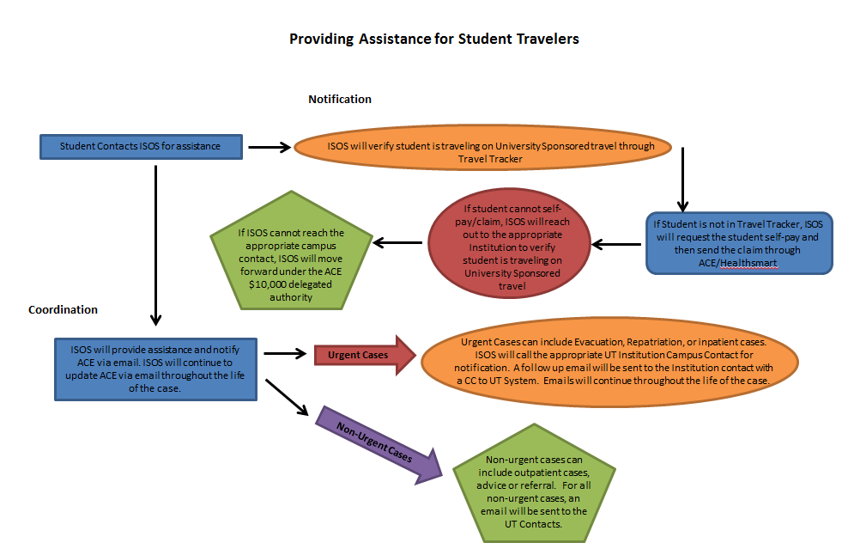

- Will the insurance company provide coverage to those students for the period received from ISOS?
The student is covered for the dates they are on official travel related to UT System institution study abroad or related educational activity outside his/her Home Country, including co-curricular and extra-curricular activities done in relation to their scholastic program while outside of the United States and their Home Country.
Please note there is a 2 week personal deviation on either side of the travel dates during which these students will be covered by our policy as well. If your students are planning to travel for a more extended period, they should arrange for insurance coverage individually.

- Will each Institution receive a bill based on the number of travelers and the travel dates reported by ISOS to the insurance company?
No. UT System Risk Management conducts an International Travel survey each year in the spring. The invoice will come from UT System and will be based on this survey data.
- How are Institutions going to collect the premium?

Institutions will decide how to allocate any premiums to students at its discretion.

- Are all students required to purchase this insurance even when travelling with study abroad companies that also provide insurance as part of the package?

Yes. All students traveling abroad will be covered by our blanket policy.

- Will faculty/staff who travel on international university sponsored business be required to purchase insurance or will they be automatically covered?

Faculty and Staff will not be covered by this policy. There is a separate ISOS agreement in place for Faculty and Staff traveling abroad for University business. For coverage for medical expenses, Faculty and Staff may be eligible for Foreign Voluntary Workers’ Compensation insurance or UT System health insurance coverage.

We are looking into more options for additional trip-specific medical expense coverage and will send more information when it is available.

- We have a professor who will be taking a group of students abroad this summer. The course is not approved for academic credit; however the trip is being promoted through the University. Travelers might include staff, faculty, students and maybe some community members. Would all of the above be required to purchase the insurance?

Students would be covered by this policy.

Community members (unless they are enrolled as a student) and travel companions will need to purchase their own coverage. Individual memberships are available through ISOS. They can provide ISOS services as well as medical expense insurance coverage. Information about individual memberships can be found on the UT System ISOS webpage under Personal Travel.

- Students travelling in their home country or country of citizenship are not eligible for coverage?
Home Country as defined by this policy is the United States, or the country as declared by the student. If a student traveling to their country of citizenship is a student of one of our Institutions, they are covered by this blanket policy and they can declare their “home country” as the USA should they choose.
We will not medically evacuate students from their home country should they choose not to be evacuated.

- Are non-credit bearing activities included and eligible for coverage (examples: athletic teams, Engineers Without Borders etc…..)?
If you are unsure of a specific situation please contact Sarah Pekar at UT System at spekar@utsystem.edu.
- How is a “study abroad program sponsored by the Participating Organization” defined?
“Participating Organization” is UT System and all UT Institutions. Study abroad program includes any sponsored travel outside of the US even those programs not specifically name “study abroad program.” If you are unsure of a specific situation please contact Sarah Pekar at UT System at spekar@utsystem.edu.
- Are students in third-party provider programs or direct enroll programs eligible?
Yes. They are eligible and covered under the Blanket Study Abroad Program.
- What is the definition of a student?
Please see response to Q1.
- How will students be enrolled in coverage?
All students are automatically enrolled by registering their trip in MyTrips on the UT System ISOS webpage and ALL students traveling internationally on a university-sponsored trip are required to register with International SOS prior to travel. It is imperative all students use the ISOS MyTrips to ensure coverage is seamless.

- How are the days and dates of coverage defined or determined?
The dates should be defined according to the dates the student is traveling for the official educational purposes, with a 2 week allowable personal deviation before and after the official travel dates.
- How is personal travel within the program dates (example: free weekend in the middle of a program) handled?
If they are within the official program dates personal travel is covered.
- What is “Personal Deviation Limited”?
2 weeks before and after the official educational purpose travel dates.
- Do students need to go to the AHP website and enroll themselves in the Study Abroad Insurance Plan for overseas travel?
No. They should register their trip on MyTrips on the UT System ISOS webpage to enroll.
Information about ISOS, the ISOS contact card and how to register trip information in MyTrips can be found here: https://www.internationalsos.com/members_home/login/login.cfm
Enter 11BSGC000037 in the Member Number field at the upper right of the page.
- Is this statement true?: Students whose departure date was August 1st and after will be covered by this plan.
YES.
- Is this statement true?: Students whose departure date was July 31st and prior will not be covered by this plan.
If a student departed prior to 8/1, they should have secured their own coverage. However, if they are still abroad after 8/1 they are covered by this blanket program. If assistance is required they should call ISOS.
- How are claims going to be handled that did not or do not involve ISOS?
Any claims which did not go through ISOS should be submitted through HealthSmart for consideration. Students are strongly encouraged to go through ISOS for any assistance.
Please see contact information below.

- Who do I contact?
To inquire about benefits, arrange coverage, or arrange emergency assistance services please contact ISOS:
1(800) 523-6586 toll free in the USA or 1 (215) 942-8478 collect, outside of the USA.
To file claims or follow up on claims submitted by the student please contact HealthSmart:
HealthSmart
3320 W. Market St., Suite 100
Fairlawn, OH 44333
1 (800) 331-1096 (Toll-Free Inside U.S. Only)
1 (330) 867-8443 (Direct Inside U.S. Only)
1 (806) 473-3136 Fax
Email: akronclaims@healthsmart.com
When you are outside of the U.S., please always call

